Learn Git in 15 minutes
video:video
Note: Notes

1)For windows, use gitbash or powershell.
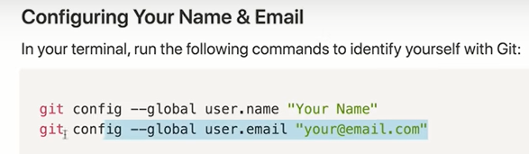

This is not use to login, but its used to see who mad what changes.
So that name and email is just used to identify yourself.
2) Git and Github are completely seperate tools.
Github does rely on git. You need to understand git to use github.
3) Repositories are containers for git.
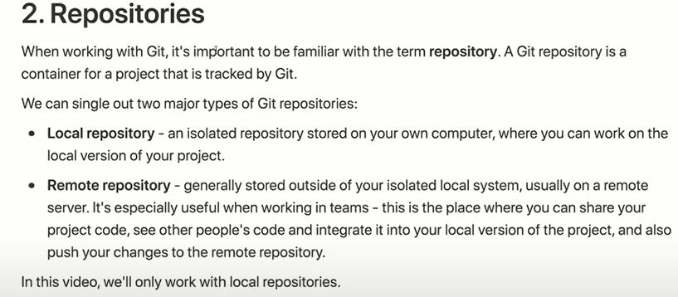

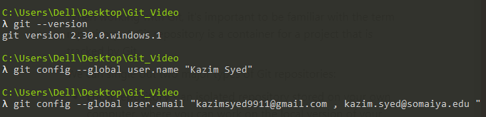
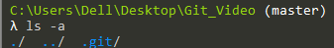

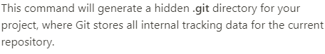

Checking the status:
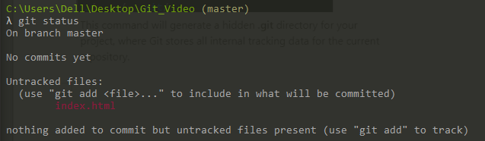

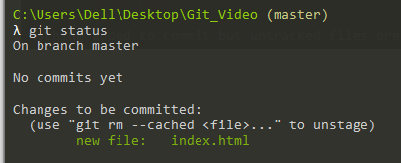

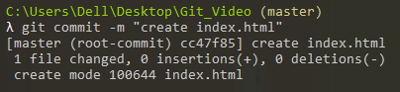

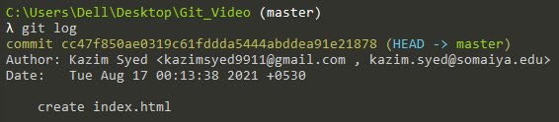
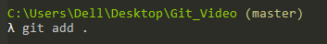

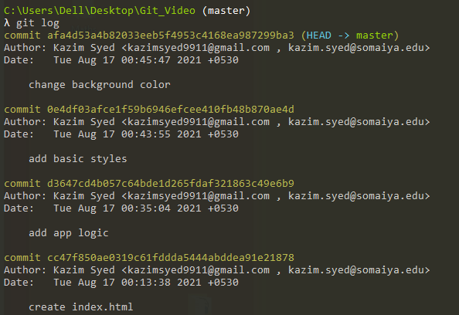
We can go back to any point in log.
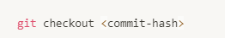
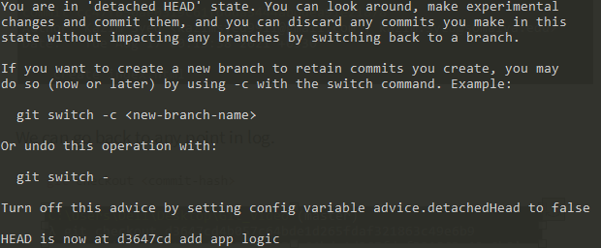

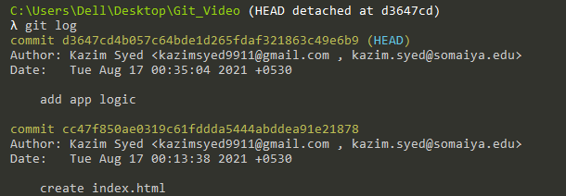
Branches
imagine you have a idea when you doing a project, n you wanna pivot and still have the ability for your team to do the project, u can create a new-timeline for your new project.
its like a timeline, a new branch. Like a new time variant branch.
With the new timeline, I can do all my work. Rather than the main branch of the app, everybody else is working on.
The main/standard branch is called master.
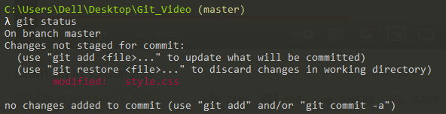
git branch : list the branches, it doesn’t create the branch.
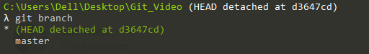

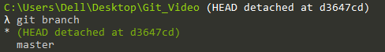

so we have master and the * tell us that we r on a different branch called head detached on d3647cd.
Whenever we go
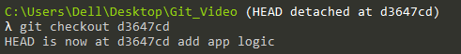

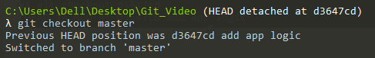

my code is back from the dead: doesn’t make sense.
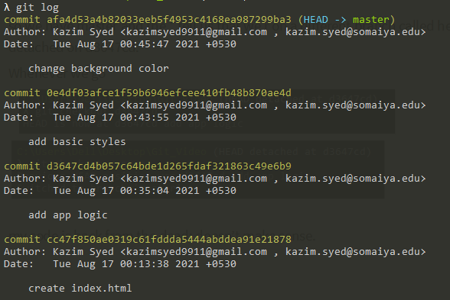
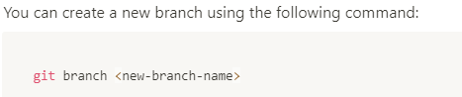

Git branch when you don’t provide the name is gonna list the branches. Git branch then a new name is gonna make a new branch.
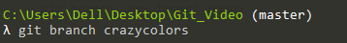
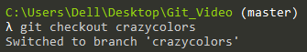
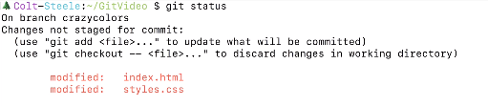

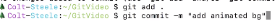
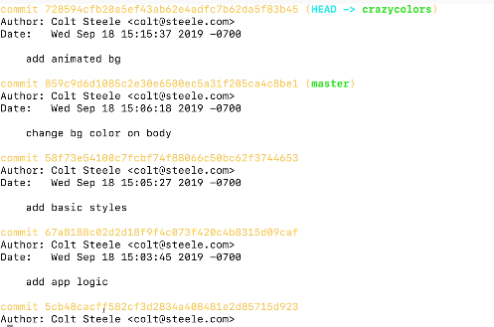

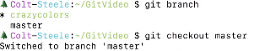

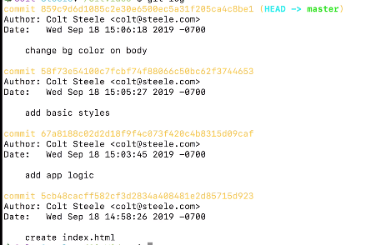

so I didn’t change my original timeline.
Colt steele:
Used when you doing a project for colt, he wanna add a exercise or etc. you don’t wanna do that until we sure we wanna adopt those changes to master.
So we work on a branch.
I make the changes and I present them to people , if they like it. We merge.
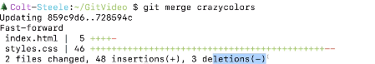

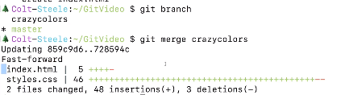

your logs also merged too.

